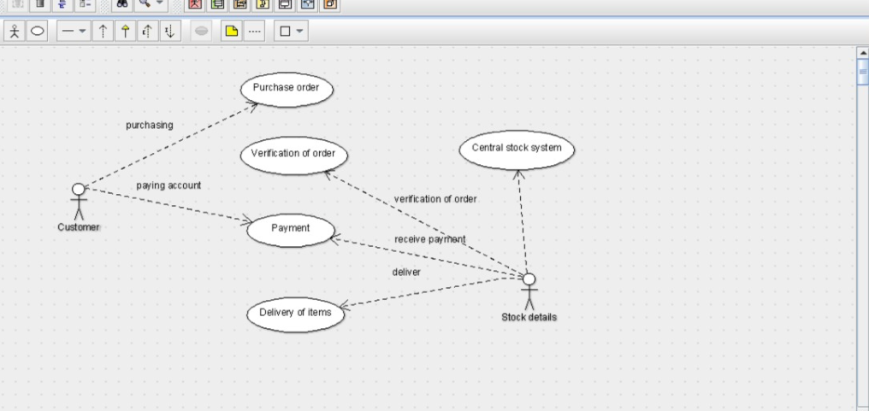USE CASE DIAGRAM

CLASS DIAGRAM

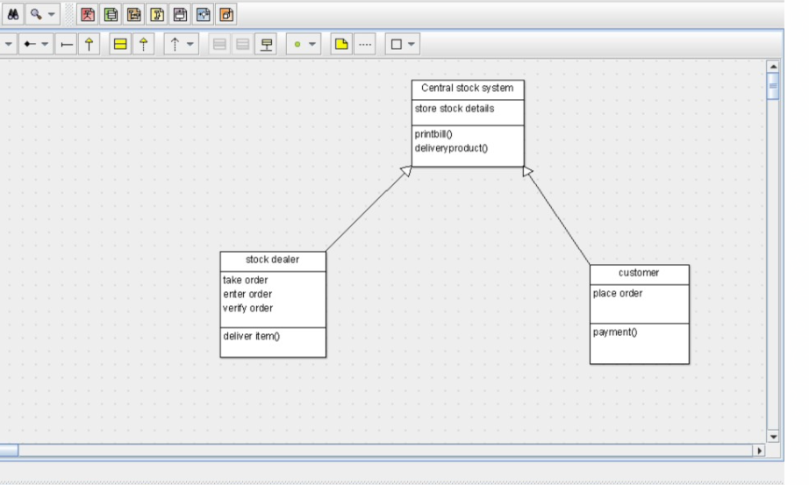

public class stock dealer extends Central stock system {

private take order;

public enter order;

public verify order;

public void deliver item() {

}

}package Central management system;

public class Student extends Central management system {

public name and address;

public marks;

public void browse() {

}

public void select() {

}

public void select() {

}package Central management system;

public class University extends Central management system {

public store details;

public verify details;

public void verify() {

}

public void enroll() {

}

SEQUENCE DIAGRAM

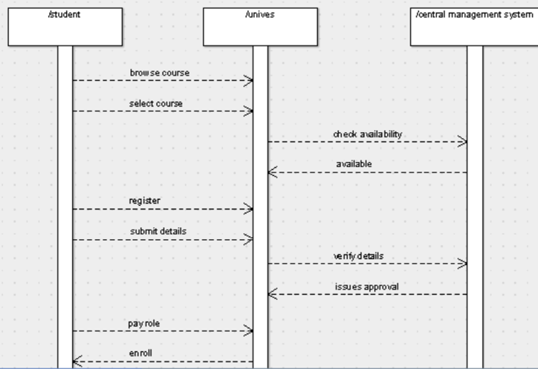

COLLABORATION DIAGRAM

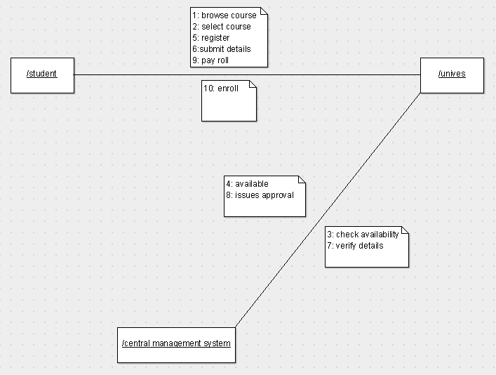

ACTIVITY DIAGRAM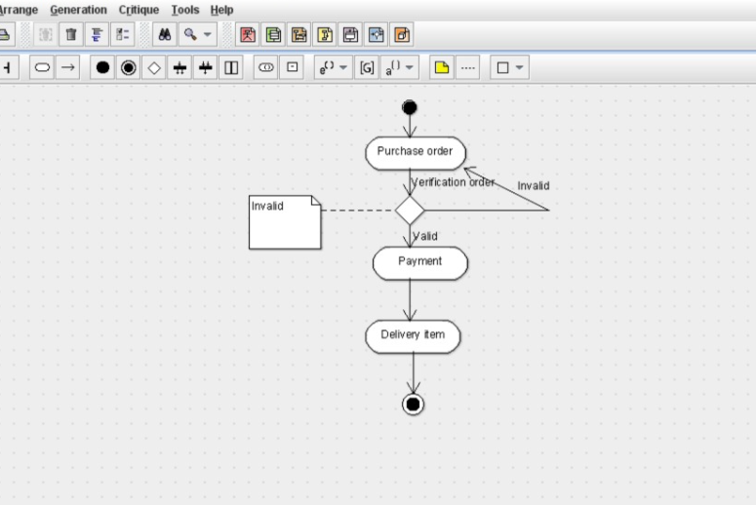

STATE CHART DIAGRAM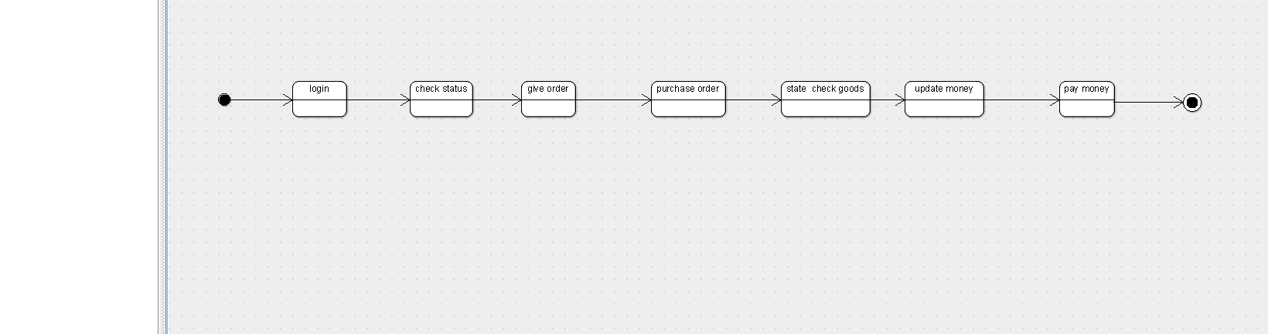

COMPONENT DIAGRAM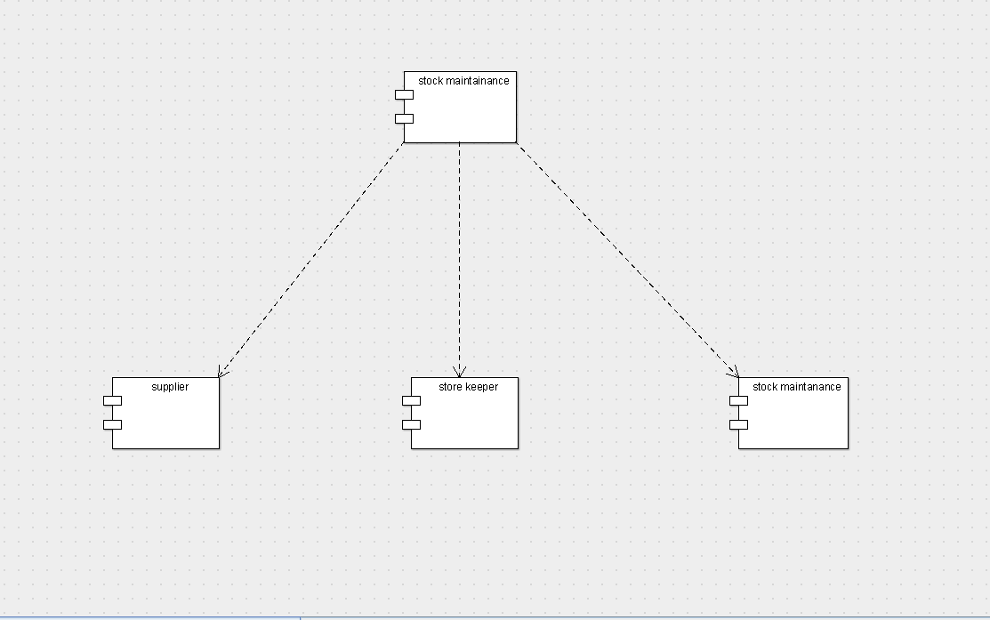

DEPLOYMENT DIAGRAM